Open Source Lab 7  
Siddharth Goyal  
9918103232  
F8

1)

import pandas as pd

data=pd.read_csv("/Users/sid404/Siddharth/College/OPEN SOURCE/Week 7/Automobile_data.csv")

data.head()

data.tail()

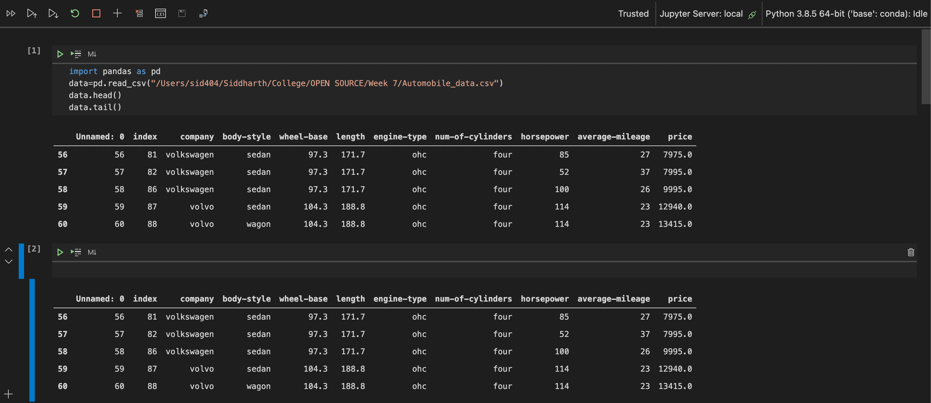

**2)**

data.replace(['?'],['Nan'])

data.replace(['n.a'],['Nan'])

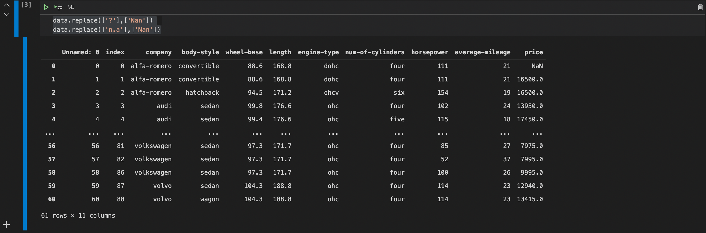

3)

volvo=data[data['company']=='volvo']

print(volvo)

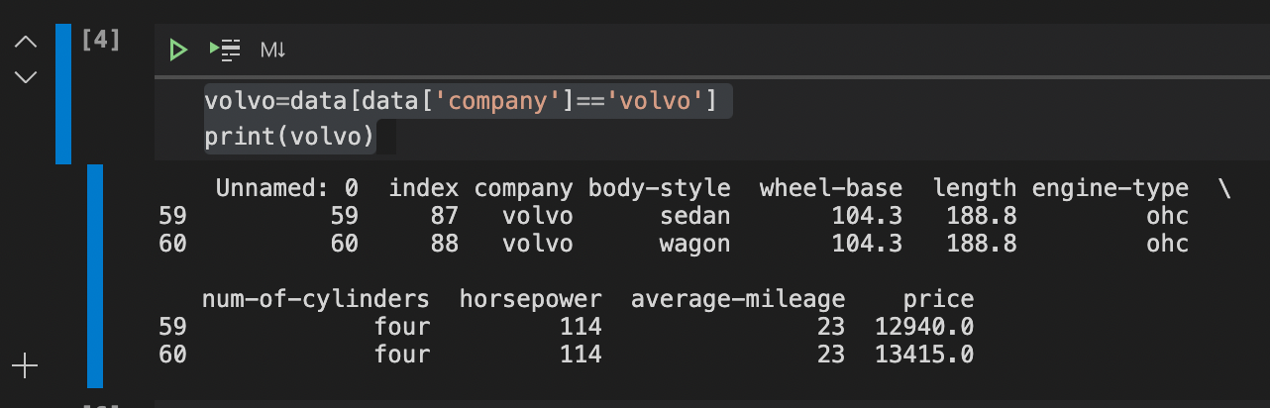

4)

data['company'].value_counts()

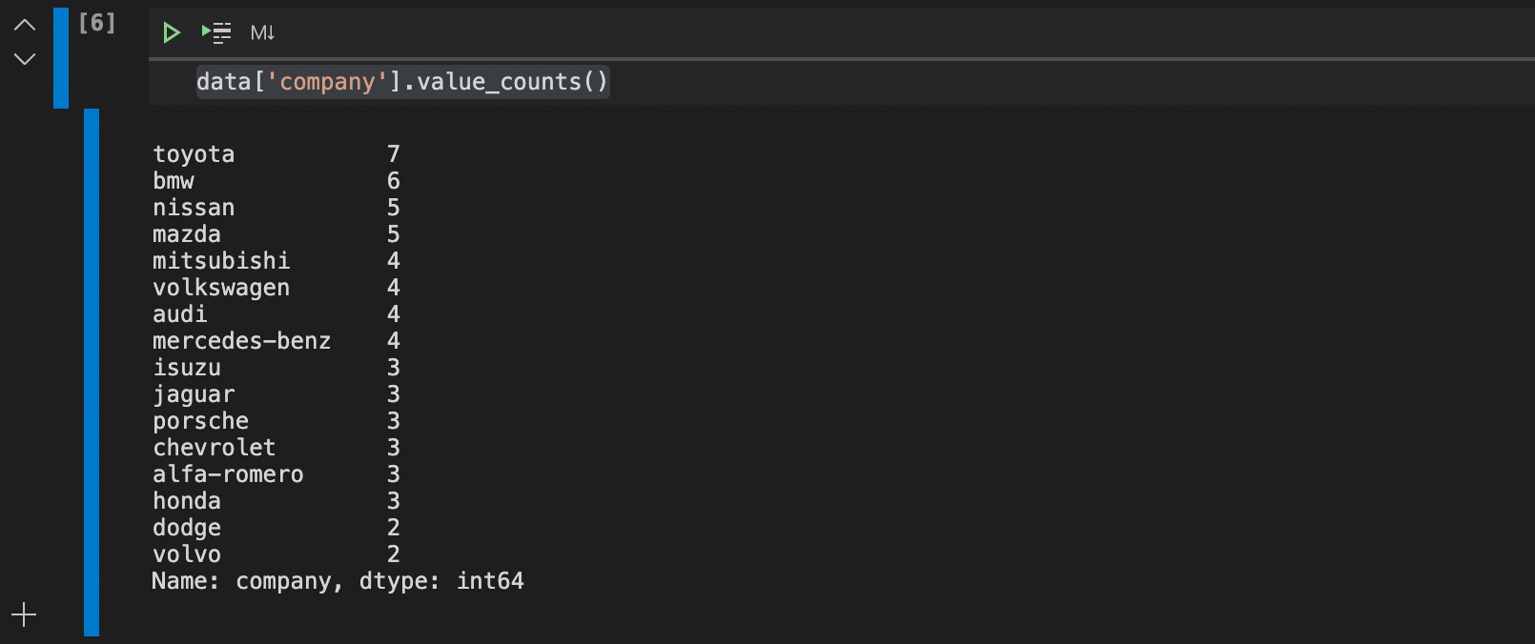

5)

company = data.groupby('company')

price = company['price'].max()

price

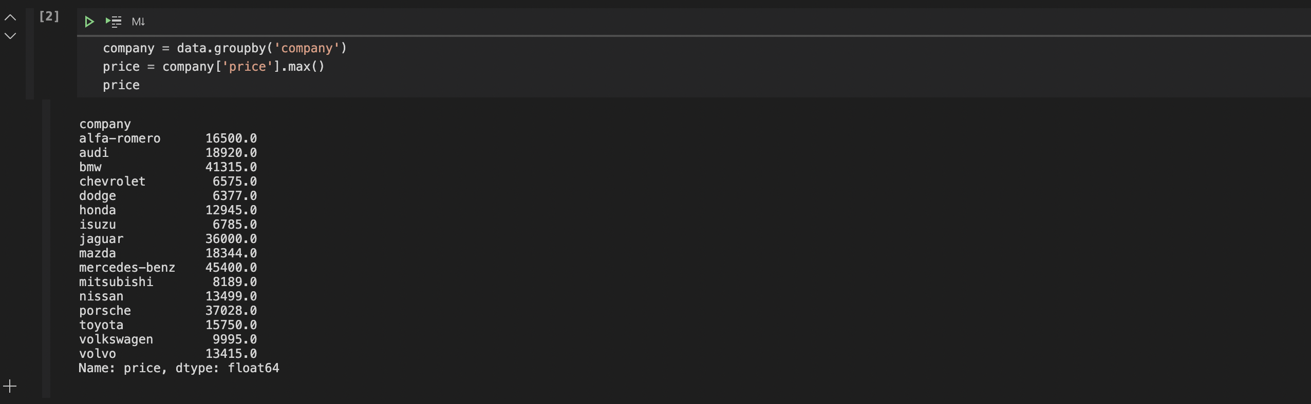

6)

mileage = company['average-mileage'].mean()

mileage

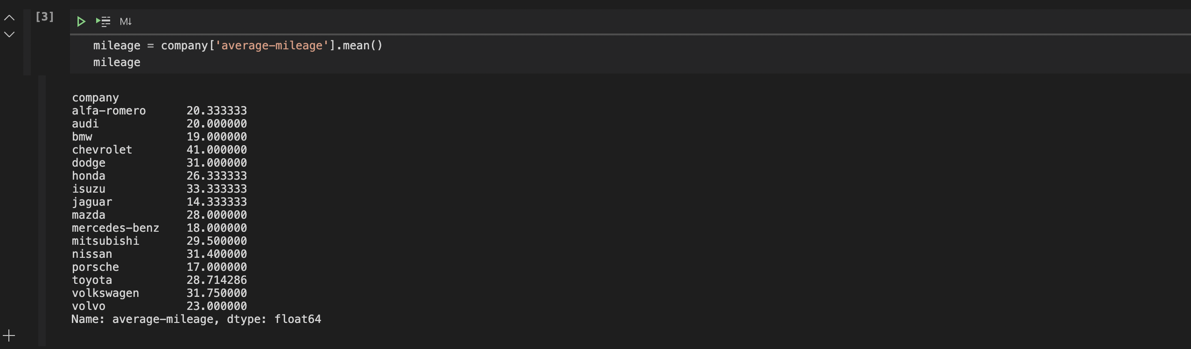

7)

Car_Price = {'Company': ['Toyota', 'Honda', 'BMV', 'Audi'], 'Price': [23845, 17995,

135925, 71400]}

Car_Price_Data=pd.DataFrame.from_dict(Car_Price)

Car_Horsepower = {'Company': ['Toyota', 'Honda', 'BMV', 'Audi'], 'horsepower': [141, 80,

182, 160]}

Car_Horsepower_Data=pd.DataFrame.from_dict(Car_Horsepower)

merged=pd.merge(Car_Price_Data,Car_Horsepower_Data, on ='Company')

merged

